Practical 2

package seleniumdriver;

import java.util.Scanner;

import org.openqa.selenium.WebDriver;

import org.openqa.selenium.chrome.ChromeDriver;

import org.openqa.selenium.firefox.FirefoxDriver;

public class STQAPrac2 {

static WebDriver wd;

public static void main(String[] args) {

System.setProperty("webdriver.chrome.driver","D:\\Newfolder\\chromedriver-win64\\chromedriver-win64\\chromedriver.exe");

Scanner sc = new Scanner(System.in);

System.out.println("1.ChromeBrowser \n2. Firefox Broswer");

System.out.println("Choice");

int ch = sc.nextInt();

sc.close();

switch (ch)

{

case 1:

System.setProperty("webdriver.chrome.driver","D:\\Newfolder\\chromedriver-win64\\chromedriver-win64\\chromedriver.exe");

wd = new ChromeDriver();

break;

case 2:

System.setProperty("webdriver.gecko.driver","D:\Newfolder\\geckodriver-v0.33.0-win64\\geckodriver.exe");

wd = new FirefoxDriver();

default:

System.out.println("Invalid Choice");

break;

}

if(wd!=null)

{

wd.get("http:\\google.com");

}

}

}

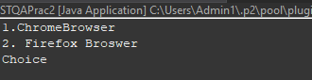.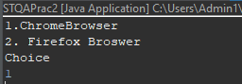

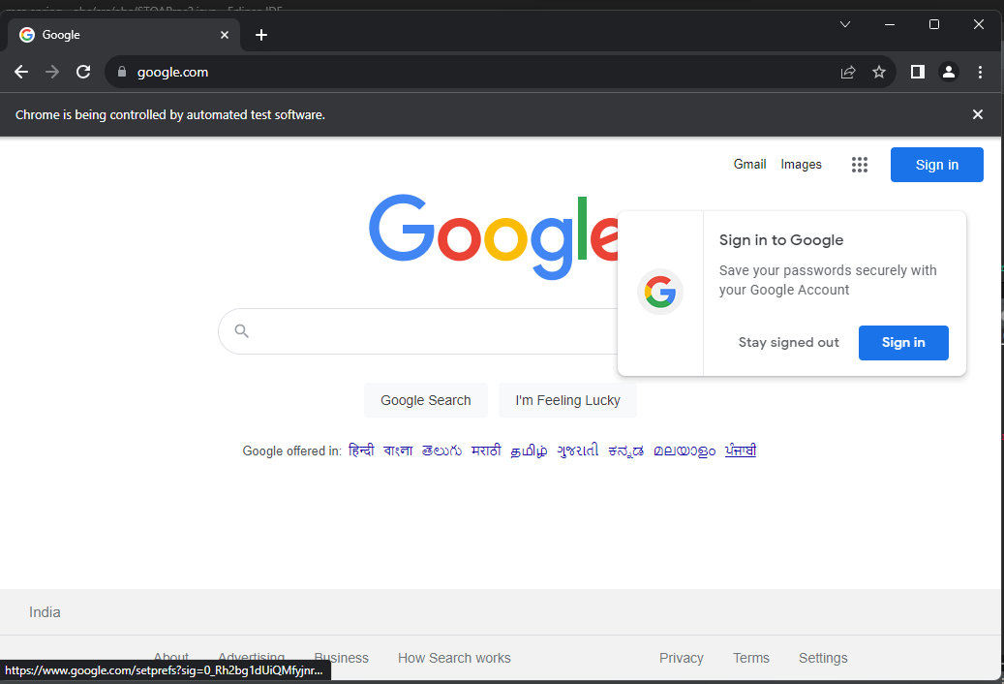

**Practical3**

package seleniumdriver;

import java.util.List;

import java.util.Scanner;

import java.util.concurrent.TimeUnit;

import org.openqa.selenium.By;

import org.openqa.selenium.WebDriver;

import org.openqa.selenium.WebElement;

import org.openqa.selenium.chrome.ChromeDriver;

import org.openqa.selenium.firefox.FirefoxDriver;

import org.openqa.selenium.interactions.Actions;

import org.openqa.selenium.support.ui.Select;

public class STQAPrac3 {

static WebDriver driver;

public static void main(String[] args) throws InterruptedException {

System.setProperty("webdriver.chrome.driver","D:\\Newfolder\\chromedriver-win64\\chromedriver-win64\\chromedriver.exe");

driver = new ChromeDriver();

driver.get("https://www.hyrtutorials.com/p/frames-practice.html");

// navigates to the page consisting an iframe

driver.manage().window().maximize();

Thread.sleep(3000);

driver.findElement(By.id("name")).sendKeys("Hello");

driver.switchTo().frame(driver.findElement(By.id("frm1")));

Thread.sleep(3000);

Select courseDD=new Select(driver.findElement(By.id("selectnav1")));

courseDD.selectByVisibleText("Contact");

driver.switchTo().defaultContent();

Thread.sleep(3000);

driver.findElement(By.id("name")).sendKeys(" World");

driver.switchTo().frame(driver.findElement(By.id("frm2")));

driver.findElement(By.id("firstName")).sendKeys("Yourname");

driver.switchTo().defaultContent();

Thread.sleep(3000);

driver.findElement(By.id("name")).sendKeys("Name");

}

}

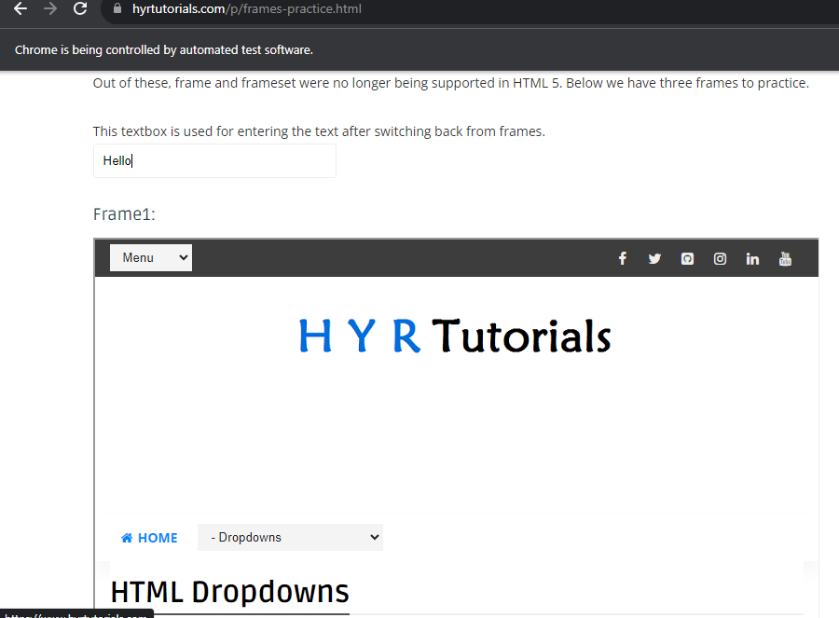

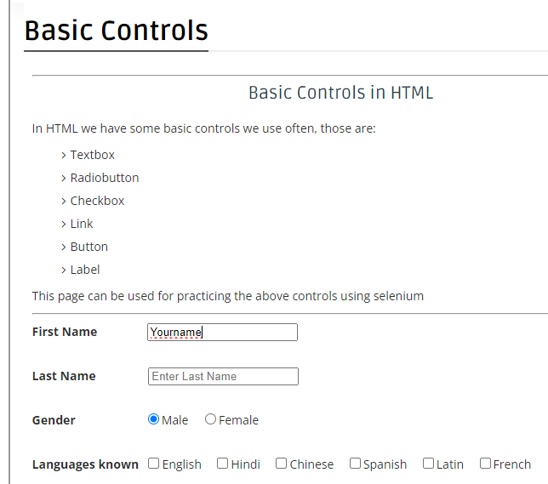

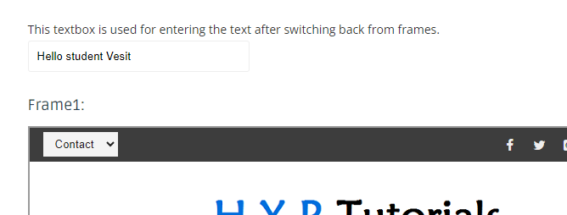

**Practical 4**

import org.openqa.selenium.WebDriver;

import org.openqa.selenium.By;

import org.openqa.selenium.JavascriptExecutor;

import org.openqa.selenium.chrome.ChromeDriver;

import org.openqa.selenium.firefox.FirefoxDriver;

import org.openqa.selenium.support.ui.WebDriverWait;

public class STQA_p4 {

public static void main(String[] args) throws InterruptedException {

System.*setProperty*("webdriver.chrome.driver","C:\\Newfolder\\chromedriver-win64 (1)\\chromedriver-win64\\chromedriver.exe");

WebDriver driver=new ChromeDriver();

driver = new ChromeDriver();

String appUrl = "https://en.wikipedia.org/wiki/Main_Page";

driver.get(appUrl);

Thread.*sleep*(2000);

// Click on Registration link

driver.findElement(By.*xpath*("//*[@id=\"pt-createaccount-2\"]/a")).click();

Thread.*sleep*(2000);

// Go back to Home Page

driver.navigate().back();

Thread.*sleep*(2000);

// Go forward to Registration page

driver.navigate().forward();

Thread.*sleep*(2000);

// Go back to Home page

driver.navigate().to(appUrl);

Thread.*sleep*(2000);

// Refresh browser

driver.navigate().refresh();

Thread.*sleep*(2000);

// Close browser

driver.close();

}

}

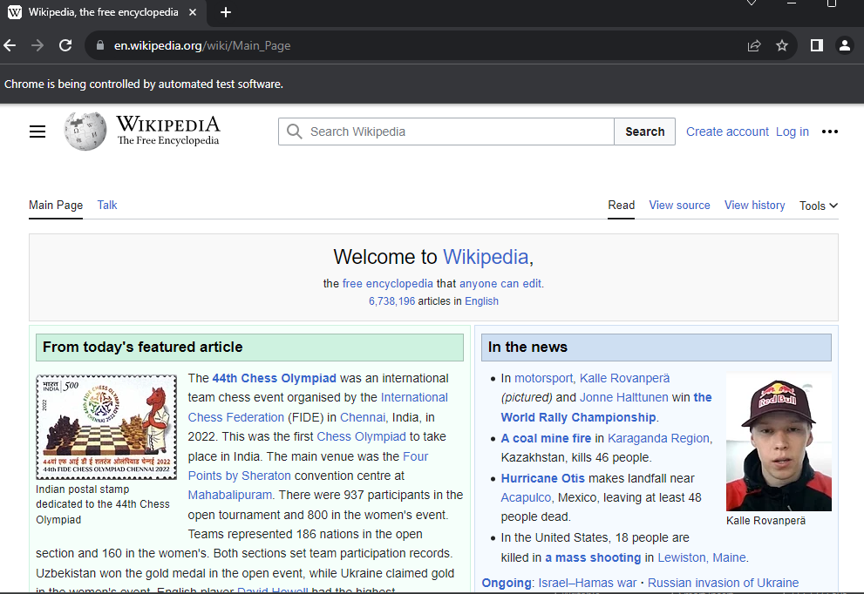

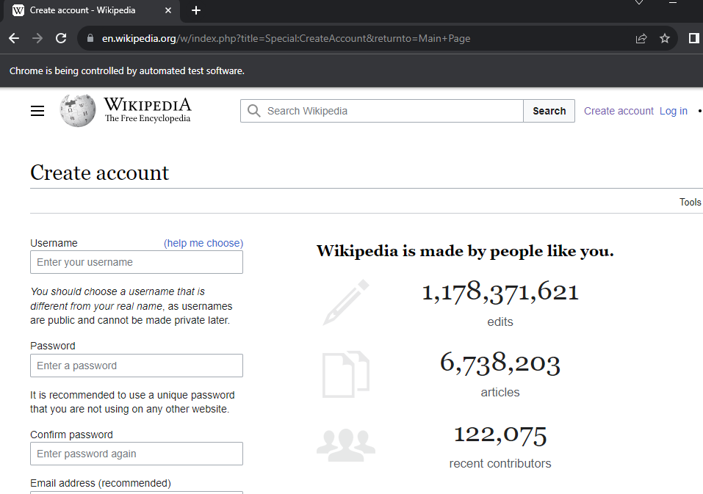

**Practical 5**

import org.openqa.selenium.WebDriver;

import org.openqa.selenium.WebElement;

import java.util.List;

import [org.openqa.selenium.By](http://org.openqa.selenium.by/);

import org.openqa.selenium.JavascriptExecutor;

import org.openqa.selenium.chrome.ChromeDriver;

import org.openqa.selenium.firefox.FirefoxDriver;

import org.openqa.selenium.support.ui.WebDriverWait;

public class findelement {

public static void main(String[] args) throws InterruptedException {

System.setProperty("webdriver.chrome.driver", "C:\\Users\\user\\Desktop\\STQA35\\chromedriver-win64 (1)\\chromedriver-win64\\chromedriver.exe");

WebDriver wd=new ChromeDriver();

wd.get("<http://demo.guru99.com/test/ajax.html>");

Thread.sleep(2000);

wd.findElement(By.id("no")).click();

Thread.sleep(2000);

wd.findElement(By.id("buttoncheck")).click();

Thread.sleep(2000);

List<WebElement> elements = wd.findElements(By.name("name"));

System.out.println("Number of elements:" +elements.size());

Thread.sleep(2000);

for (int i=0; i<elements.size();i++){

System.out.println("Radio button text:" + elements.get(i).getAttribute("value"));

Thread.sleep(2000);

}

}

}

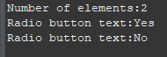

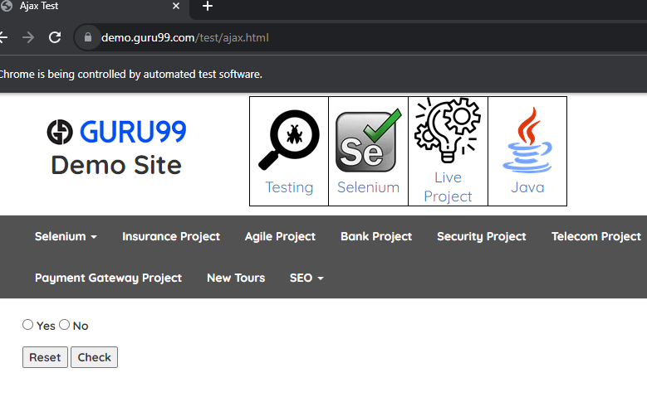

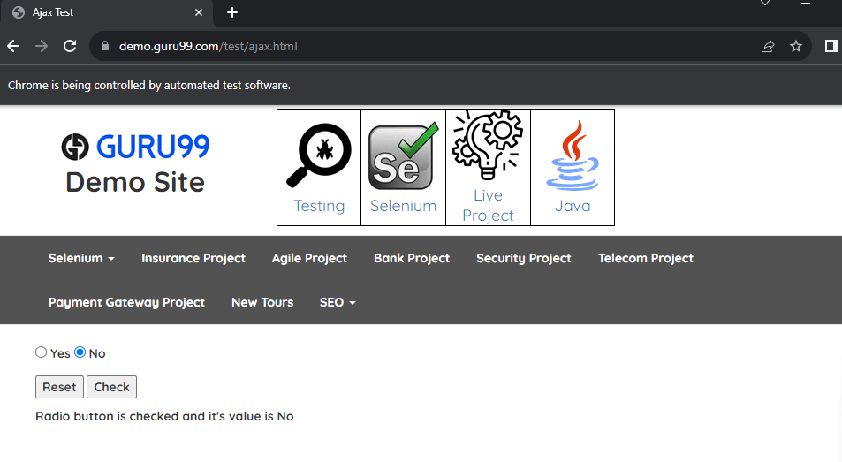

**Practical 6**

package seleniumdriver;

import org.openqa.selenium.WebDriver;

import org.openqa.selenium.WebElement;

import java.util.List;

import java.util.concurrent.TimeUnit;

import [org.openqa.selenium.By](http://org.openqa.selenium.by/);

import org.openqa.selenium.JavascriptExecutor;

import org.openqa.selenium.chrome.ChromeDriver;

import org.openqa.selenium.firefox.FirefoxDriver;

import org.openqa.selenium.support.ui.WebDriverWait;

public class STQAPrac6 {

public static void main(String[] args) throws InterruptedException {

System.setProperty("webdriver.chrome.driver", "D:\\Newfolder\\chromedriver-win64\\chromedriver-win64\\chromedriver.exe");

WebDriver driver = new ChromeDriver();

String url = "<https://www.hackerrank.com/auth/login>";

driver.get(url);

Thread.sleep(1000);

System.out.println("HackerRank opened");

driver.findElement(By.name("username")).sendKeys("tester.stqa@gmail.com");

driver.findElement(By.cssSelector("input[type=password]")).sendKeys("tester");

driver.findElement(By.cssSelector("button.auth-button")).click();

System.out.println("Credentials Entered");

Thread.sleep(6000);

driver.findElement(

By.xpath("/html/body/div[4]/div/div/div/div/div[1]/nav/div/div[2]/ul[1]/li/div/div/div/div/input")) .sendKeys("Tower Breakers");

Thread.sleep(6000);

System.out.println("Question Searched");

driver.findElement(By.xpath("/html/body/div[4]/div/div/div/div/div[1]/nav/div/div[2]/ul[1]/ li/div/div/div/div[2]/ul/li[8]/div/div"))

.click();

Thread.sleep(6000);

driver.findElement(By.className("profile-menu")).click();

Thread.sleep(6000);

driver.findElement(By.className("logout-button")).click();

Thread.sleep(2000);

System.out.println("Logged out");

}

}

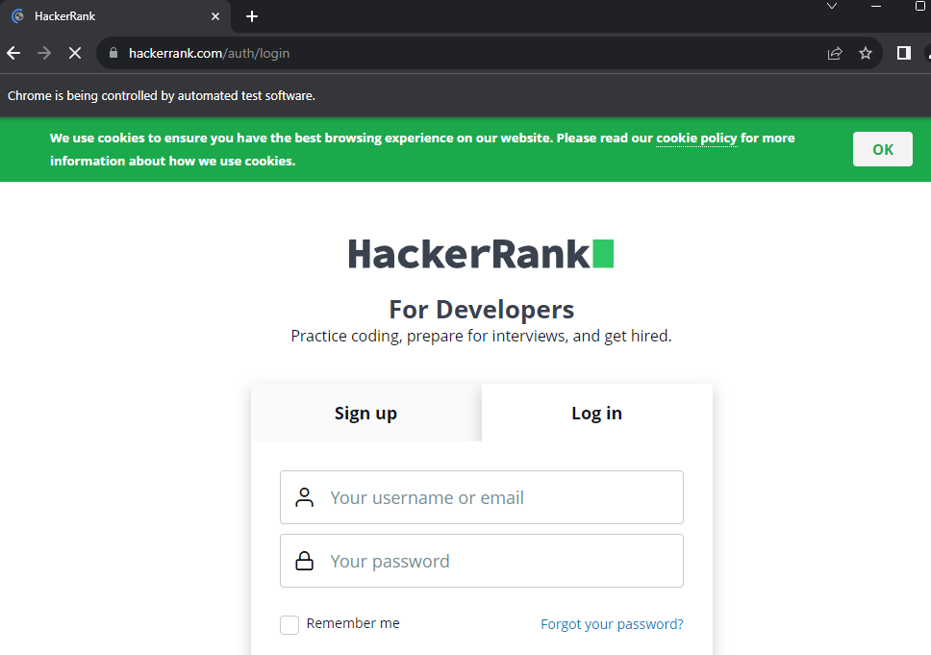

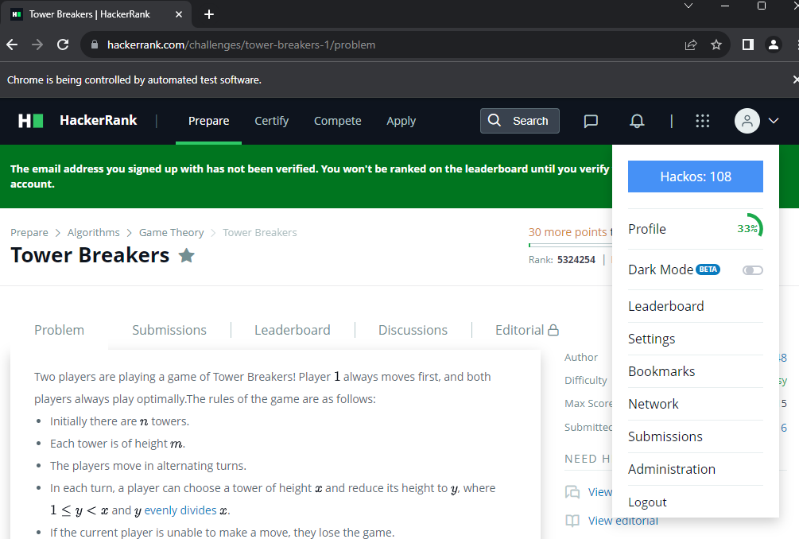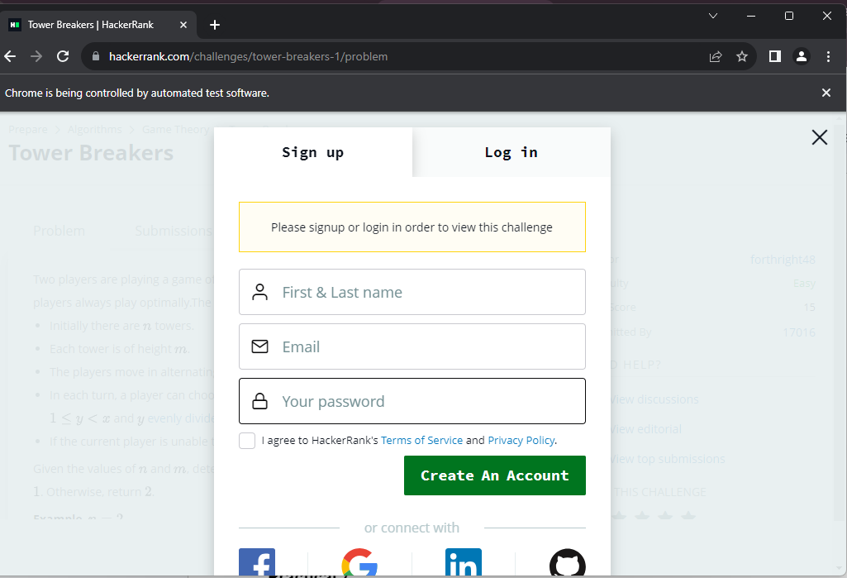

**Practical 7**

import org.openqa.selenium.WebDriver;

import org.openqa.selenium.WebElement;

import java.util.List;

import java.util.concurrent.TimeUnit;

import org.openqa.selenium.By;

import org.openqa.selenium.JavascriptExecutor;

import org.openqa.selenium.chrome.ChromeDriver;

import org.openqa.selenium.firefox.FirefoxDriver;

import org.openqa.selenium.support.ui.WebDriverWait;

public class PRAC7 {

public static void main(String[] args) throws InterruptedException {

System.*setProperty*("webdriver.chrome.driver","C:\\Newfolder\\chromedriver-win64 (1)\\chromedriver-win64\\chromedriver.exe");

WebDriver wd=new ChromeDriver();

wd.get("https://opensource-demo.orangehrmlive.com/");

wd.findElement(By.*id*("txtUsername")).sendKeys("admin");//locator id

wd.manage().timeouts().~~implicitlyWait~~(10,*TimeUnit*.***SECONDS***);//implicit wait

wd.findElement(By.*name*("txtPassword")).sendKeys("admin123");

wd.findElement(By.*className*("button")).click();//locatorclassName

wd.findElement(By.*partialLinkText*("Welcome")).click();//locatorpartiallinkTex

wd.findElement(By.*xpath*("//*[@id=\"welcome\"]")).click();

wd.findElement(By.*linkText*("Logout")).click();//locator linkTex

}

}

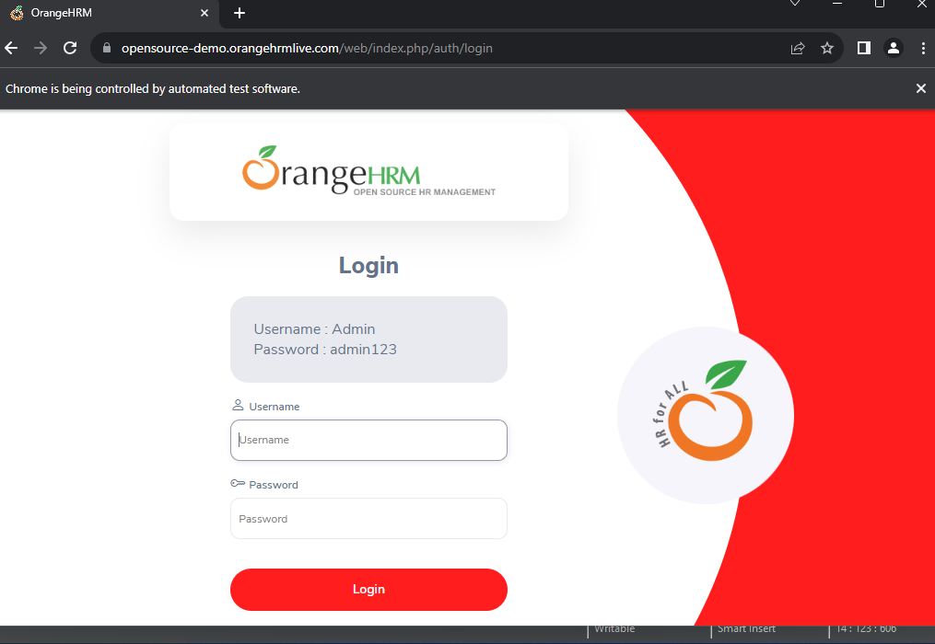

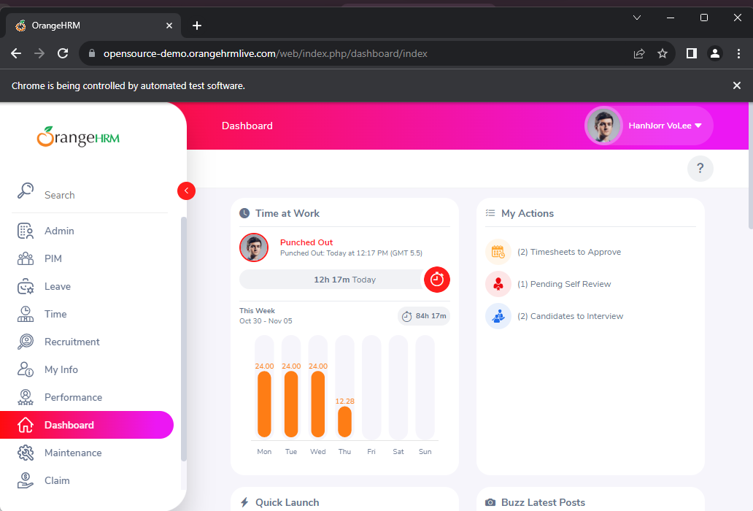

**Practical 8**

import org.openqa.selenium.Alert;

import [org.openqa.selenium.By](http://org.openqa.selenium.by/);

import org.openqa.selenium.WebDriver;

import org.openqa.selenium.chrome.ChromeDriver;

public class alert{

public static void main(String[] args) throws InterruptedException {

System.setProperty("webdriver.chrome.driver","C:\\Users\\user\\Desktop\\STQA35\\chromedriver-win64 (1)\\chromedriver-win64\\chromedriver.exe");

WebDriver webDriver = new ChromeDriver();

webDriver.get("<https://demo.automationtesting.in/Alerts.html>");

Thread.sleep(2000);

webDriver.findElement(By.xpath("/html/body/div[1]/div/div/div/div[2]/div[1]/button")).click();

Thread.sleep(2000);

// Switching to Alert

Alert alert = webDriver.switchTo().alert();

// Capturing and printing alert message.

System.out.println(webDriver.switchTo().alert().getText());

alert.accept();

Thread.sleep(2000);

webDriver.findElement(By.xpath("/html/body/div[1]/div/div/div/div[1]/ul/li[2]/a")).click();

Thread.sleep(2000);

webDriver.findElement(By.xpath("/html/body/div[1]/div/div/div/div[2]/div[2]/button")).click();

Thread.sleep(2000);

// Switching to Alert

alert = webDriver.switchTo().alert();

// Capturing and printing alert message.

System.out.println(webDriver.switchTo().alert().getText());

alert.accept();

webDriver.findElement(By.xpath("/html/body/div[1]/div/div/div/div[1]/ul/li[3]/a")).click();

Thread.sleep(2000);

webDriver.findElement(By.xpath("/html/body/div[1]/div/div/div/div[2]/div[3]/button")).click();

Thread.sleep(2000);

// Switching to Alert

alert = webDriver.switchTo().alert();

alert.sendKeys("ABC");

Thread.sleep(2000);

// Capturing and printing alert message.

System.out.println(webDriver.switchTo().alert().getText());

alert.accept();

System.out.println(webDriver.findElement(By.xpath("/html/body/div[1]/div/div/div/div[2]/div[3]/p")).getText());

Thread.sleep(2000);

webDriver.close();

}

}

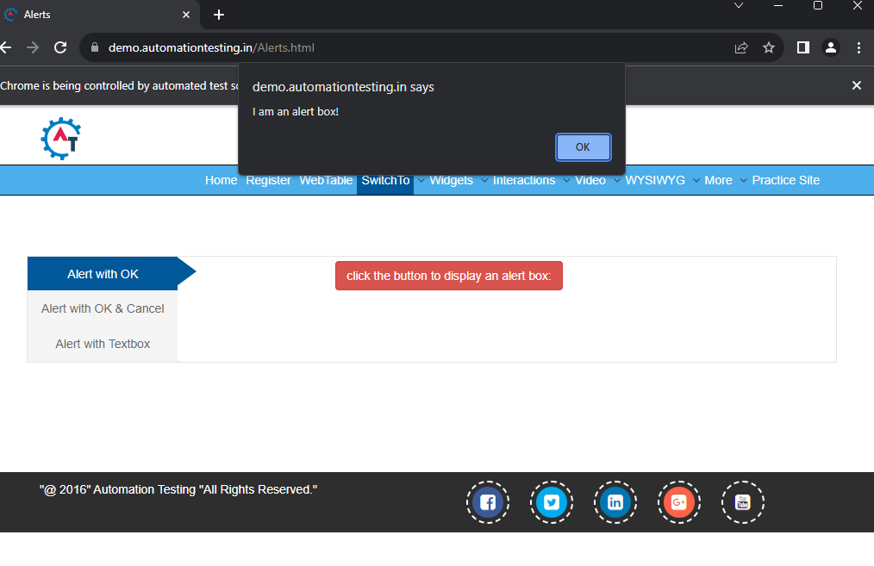

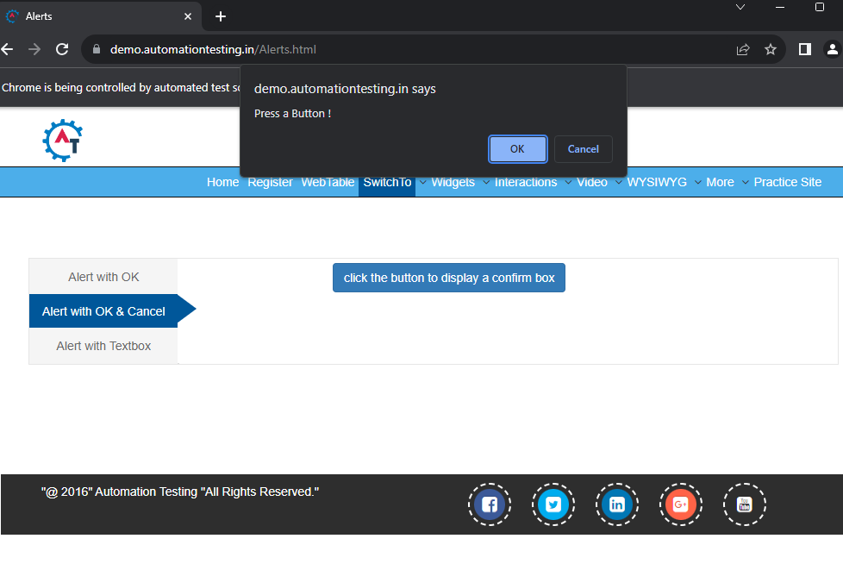

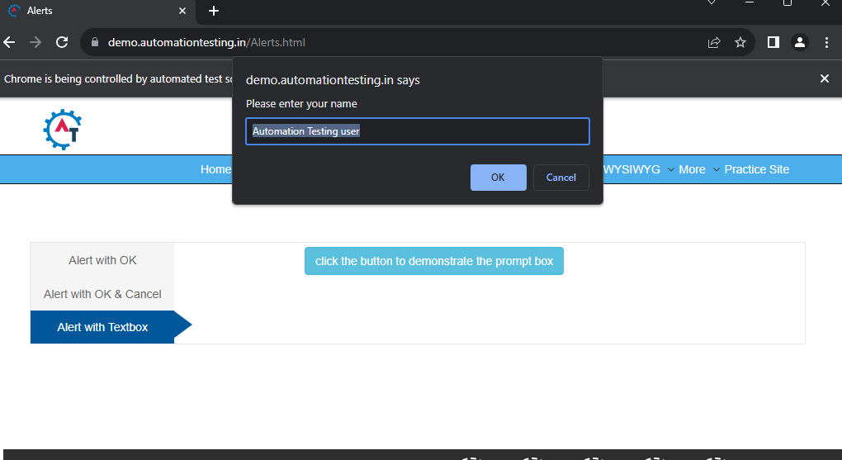

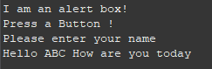

**Practical 9**

import org.openqa.selenium.WebDriver;

import org.openqa.selenium.WebElement;

import java.util.List;

import java.util.concurrent.TimeUnit;

import [org.openqa.selenium.By](http://org.openqa.selenium.by/);

import org.openqa.selenium.JavascriptExecutor;

import org.openqa.selenium.chrome.ChromeDriver;

import org.openqa.selenium.firefox.FirefoxDriver;

import org.openqa.selenium.support.ui.WebDriverWait;

public class sync {

public static void main(String[] args) throws InterruptedException {

System.setProperty("webdriver.chrome.driver", "C:\\Users\\user\\Desktop\\STQA35\\chromedriver-win64 (1)\\chromedriver-win64\\chromedriver.exe");

WebDriver wd=new ChromeDriver();

wd.get("<https://opensource-demo.orangehrmlive.com/>");

wd.findElement(By.id("txtUsername")).sendKeys("admin");//locator id

wd.manage().timeouts().implicitlyWait(10,TimeUnit.SECONDS);//implicit wait

wd.findElement(By.name("txtPassword")).sendKeys("admin123");

wd.findElement(By.className("button")).click();//locatorclassName2

wd.findElement(By.partialLinkText("Welcome")).click();//locatorpartiallinkTex

wd.findElement(By.xpath("//*[@id=\"welcome\"]")).click();

wd.findElement(By.linkText("Logout")).click();//locator linkTex

}

}

**Practical 10**

import org.openqa.selenium.WebDriver;

import org.openqa.selenium.WebElement;

import java.util.List;

import java.util.concurrent.TimeUnit;

import org.openqa.selenium.Alert;

import org.openqa.selenium.By;

import org.openqa.selenium.JavascriptExecutor;

import org.openqa.selenium.chrome.ChromeDriver;

import org.openqa.selenium.firefox.FirefoxDriver;

import org.openqa.selenium.support.ui.ExpectedConditions;

import org.openqa.selenium.support.ui.Select;

import org.openqa.selenium.support.ui.WebDriverWait;

public class StqaPrac10 {

public static void main(String[] args) throws InterruptedException {

System.setProperty("webdriver.chrome.driver",

"C:\\Users\\KrushnaSQTA\\Downloads\\chromedriver-win64\\chromedriver-win64\\chro

medriver.exe");

WebDriver driver = new ChromeDriver();

driver.get("https://demo.guru99.com/test/radio.html");

WebElement radio1 = driver.findElement(By.id("vfb-7-1"));

WebElement radio2 = driver.findElement(By.id("vfb-7-2"));

// Radio Button1 is selected

radio1.click();

System.out.println("Radio Button Option 1 Selected");

// Radio Button1 is deselected and Radio Button2 is selected

radio2.click();

System.out.println("Radio Button Option 2 Selected");

// Selecting CheckBox

WebElement option1 = driver.findElement(By.id("vfb-6-0"));

// This will Toggle the Check box

option1.click();

// Check whether the Check box is toggled on

if (option1.isSelected()) {

System.out.println("Checkbox is Toggled On");

} else {

System.out.println("Checkbox is Toggled Off");

}

Thread.sleep(5000);

// Selecting Checkbox and using isSelected Method

driver.get("http://demo.guru99.com/test/facebook.html");

WebElement chkFBPersist = driver.findElement(By.id("persist_box"));

for (int i = 0; i < 2; i++) {

chkFBPersist.click();

System.out.println("Facebook Persists Checkbox Statusis - " +

chkFBPersist.isSelected());

}

Thread.sleep(5000);

driver.close();

}

}

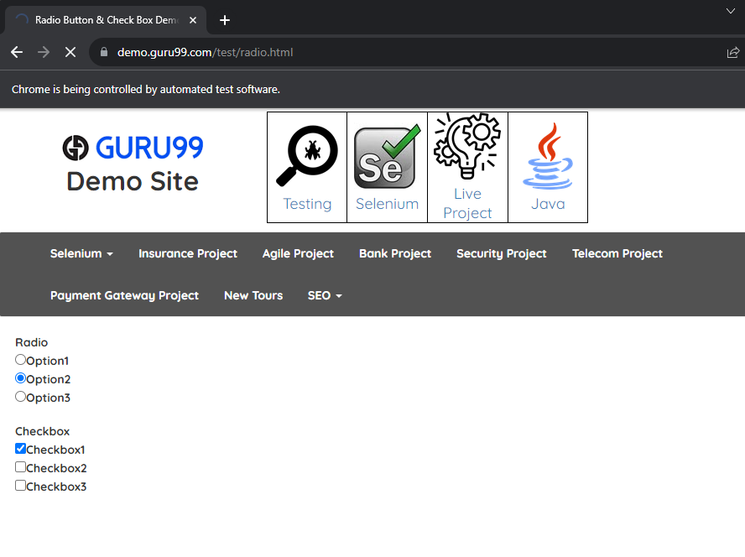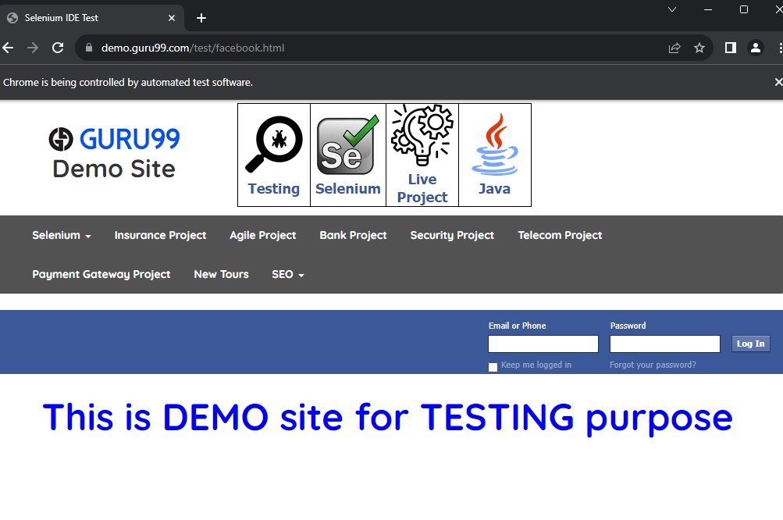

**Practical 11**

import org.openqa.selenium.WebDriver;

import org.openqa.selenium.WebElement;

import java.util.List;

import java.util.concurrent.TimeUnit;

import org.openqa.selenium.Alert;

import org.openqa.selenium.By;

import org.openqa.selenium.JavascriptExecutor;

import org.openqa.selenium.chrome.ChromeDriver;

import org.openqa.selenium.firefox.FirefoxDriver;

import org.openqa.selenium.interactions.Actions;

import org.openqa.selenium.support.ui.ExpectedConditions;

import org.openqa.selenium.support.ui.Select;

import org.openqa.selenium.support.ui.WebDriverWait;

public class StqaPrac11 {

public static void main(String[] args) throws InterruptedException { **System.setProperty("webdriver.chrome.driver",**

**"C:\\Users\\KrushnaSQTA\\Downloads\\chromedriver-win64\\chromedriver-win64\\c hromedriver.exe");**

WebDriver wd = new ChromeDriver();

wd.get("https://practicetestautomation.com/practice-test-login/");

wd.manage().timeouts().implicitlyWait(10,TimeUnit.SECONDS);

wd.findElement(By.id("username")).sendKeys("student");//locator id wd.findElement(By.id("password")).sendKeys("Password123");//locater nam Thread.sleep(5000);

wd.findElement(By.id("submit")).click();//locatorclassName

Actions act = new Actions(wd);

List<WebElement> menu =

wd.findElements(By.xpath("/html/body/div/div/header/div[3]/div[1]/div/div[2]/div/nav/ul") );

for (int i = 0; i <= menu.size() - 1; i++) {

System.out.println(menu.get(i).getText());//print text ofall the element on console

act.moveToElement(menu.get(i)).perform();//toperform mousehover on all elements of list

Thread.sleep(5000);

}

//wd.navigate().to("https://practicetestautomation.com/practice-test-login/");

wd.findElement(By.xpath("/html/body/div/div/section/div/div/article/div[2]/div/div/div/a")). click();

Thread.sleep(2000);

System.out.println("Logout");

wd.close();

}

}

